Lab Task#2

Saad Ahmad

20P-0051

**Task 1 (a)**

**Step 1:**

Open Cisco Packet Tracer application

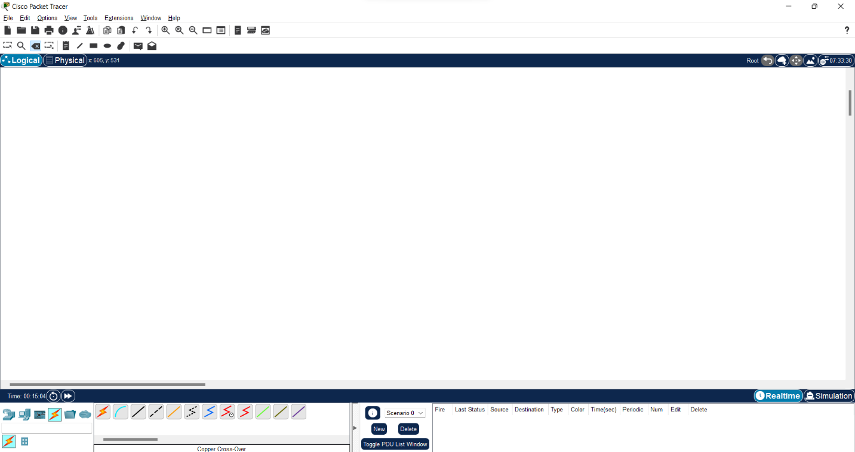

**Step 2:**

At the left bottom select **End devices** and then select **PC** and select 2 PC from them.

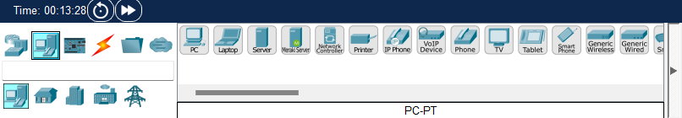

**Step 3:**

Set the IP address for each device

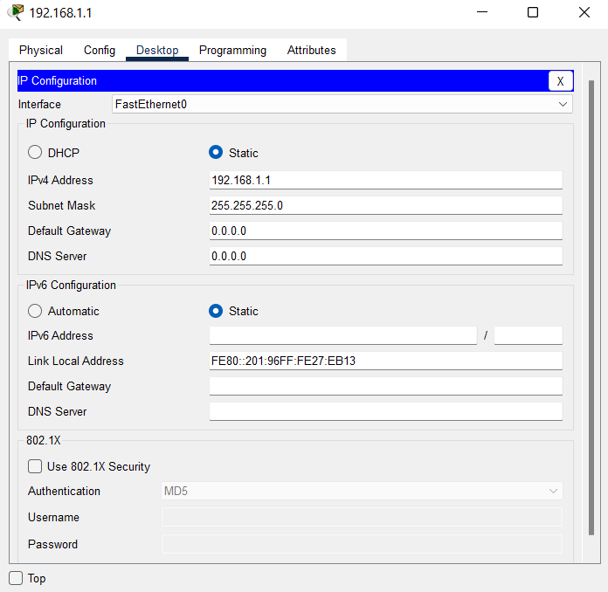

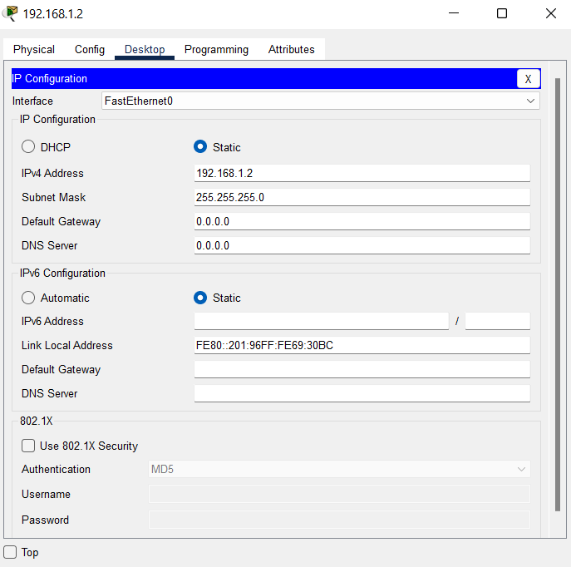

**Step 4:**

Now we will make a connection between the two devices so for go to the **Connection** tab and select the copper cross over cable and make a connection between them.

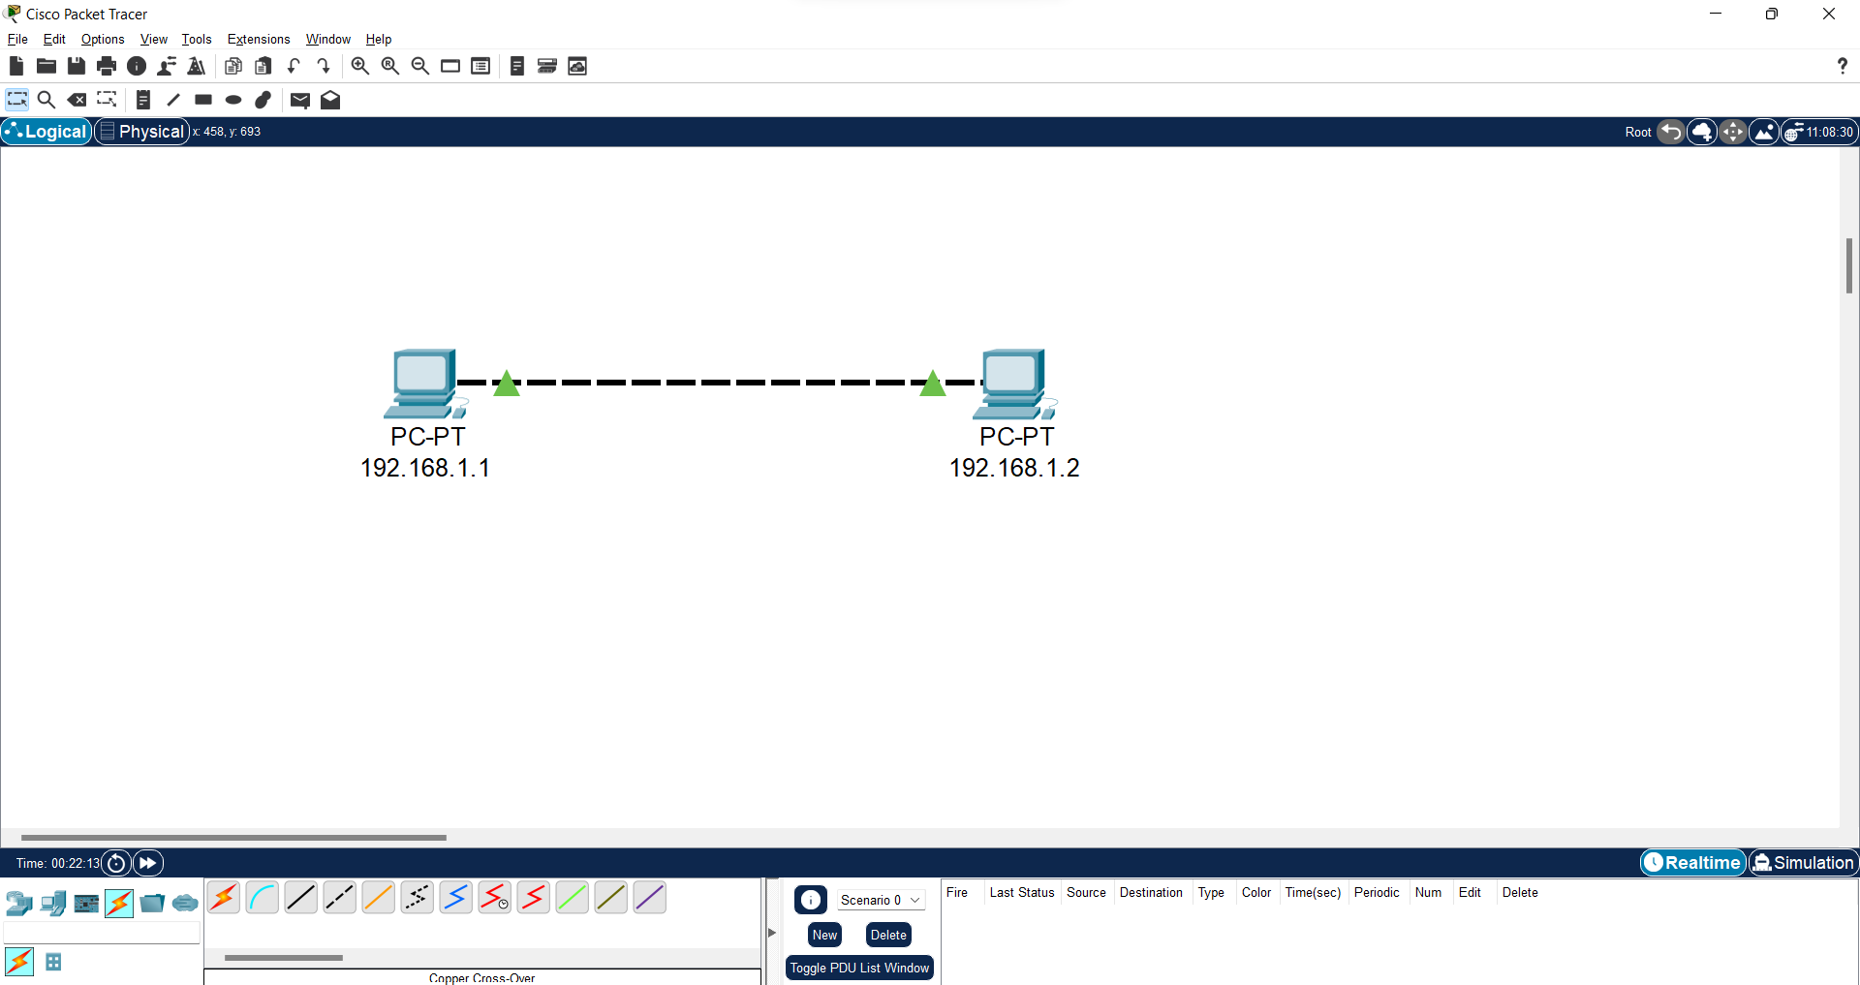

**Step 5:**

Now that we have connected the devices, we will test the connection so for that double click on the PC-1 and select the command prompt.

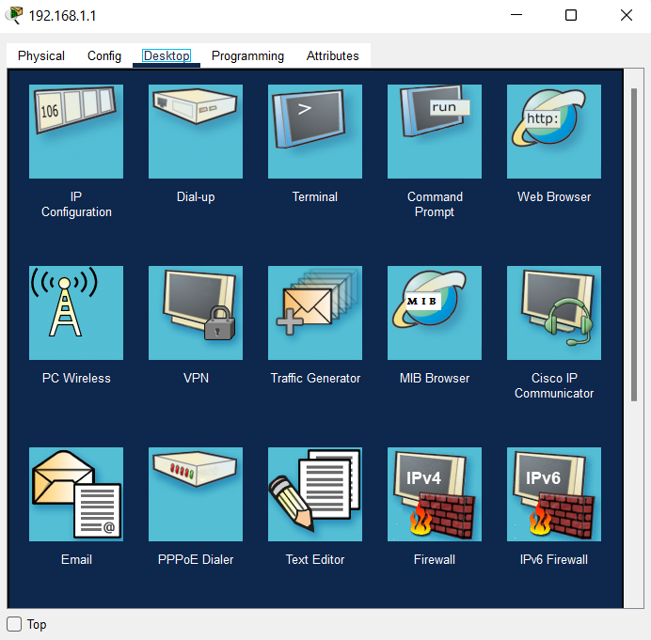

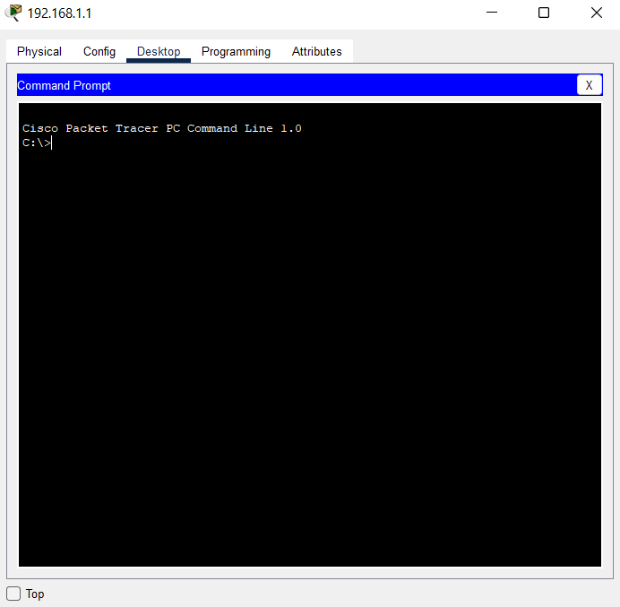

**Step 6:**

Now type the **ping <name of the other device>** and you will see the following result.

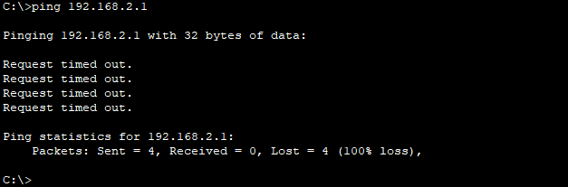

**Task 1 (b)**

**Step 1:**

Now set the IP of the first device to IPv4: 192.168.1.1 Subnet mask: 255.255.255.0 and the IP of the second device to: IPv4: 192.168.2.1 Subnet mask: 255.255.255.0

**Step 2:**

Now check the connection and using the same ping command.

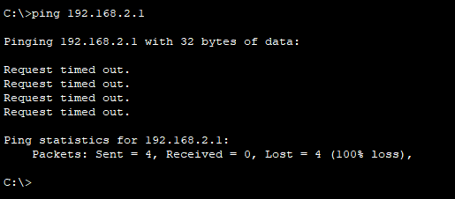

**Reason:** Both the devices are on the different networks because there IPs are different.

**Task 1 (c)**

**Step 1:**

Now set the IP of the first device to IPv4: 192.168.1.1 Subnet mask: 255.255.0.0 and the IP of the second device to IPv4: 192.168.2.1 Subnet mask: 255.255.0.0

**Step 2:**

Now check the connection and using the same ping command.

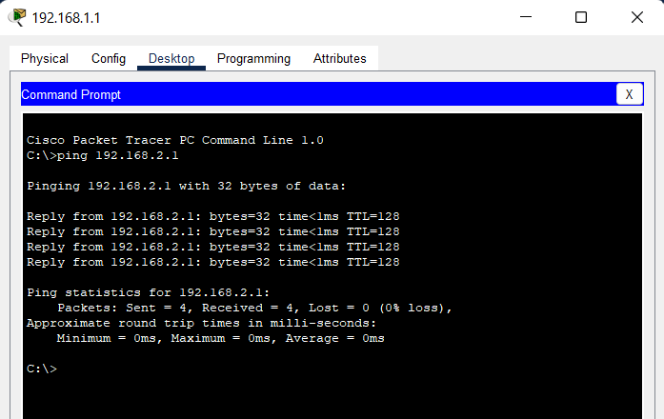

**Reason:** although the IP addresses are different but the net mask are same so it will check the first 2 values which are some so that is why the is a connection between the two devices.

**Task 2**

**Using HUB:**

**Step 1:**

Place all the devices and place the hub at the center of them and connect them with the copper straight through cable

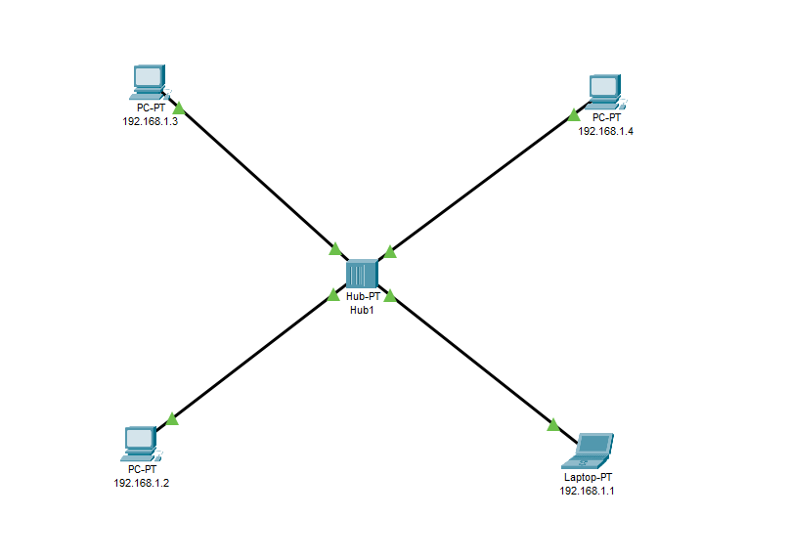

**Step 2:**

Now assign the IPs to each of the system.

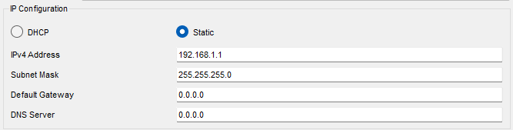

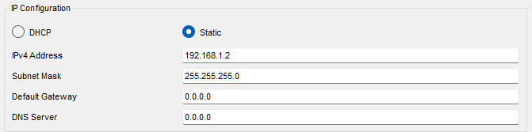

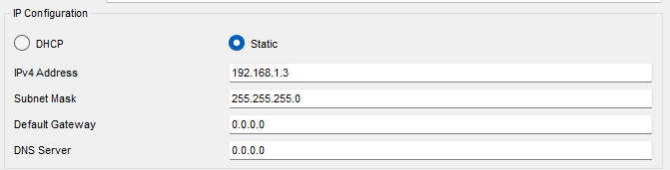

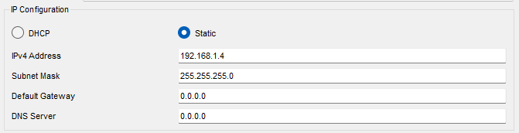

**Step 3:**

Now select the message and add the source and the destination.

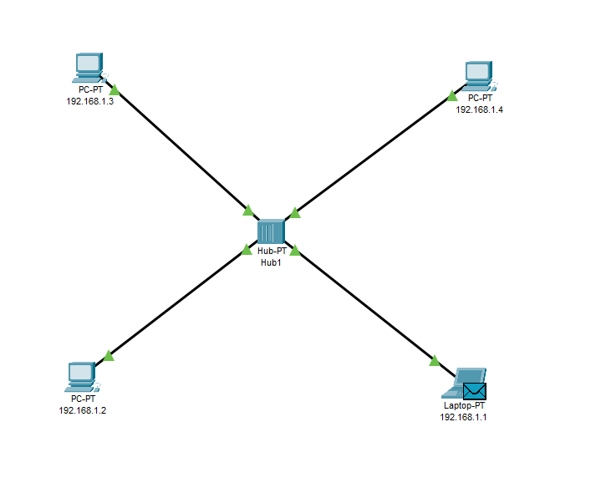

**Simulation:**

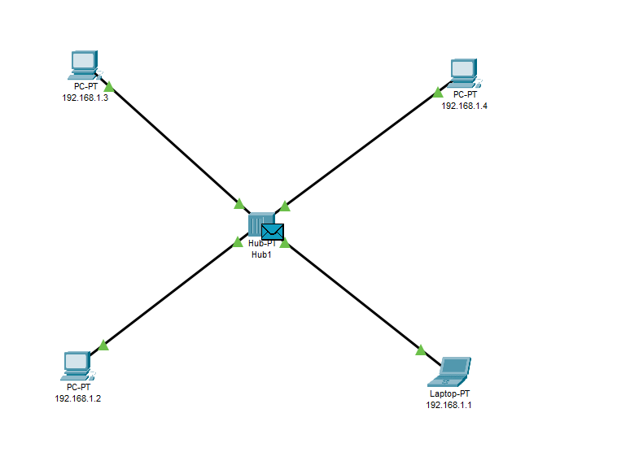

Message is sent to the HUB.

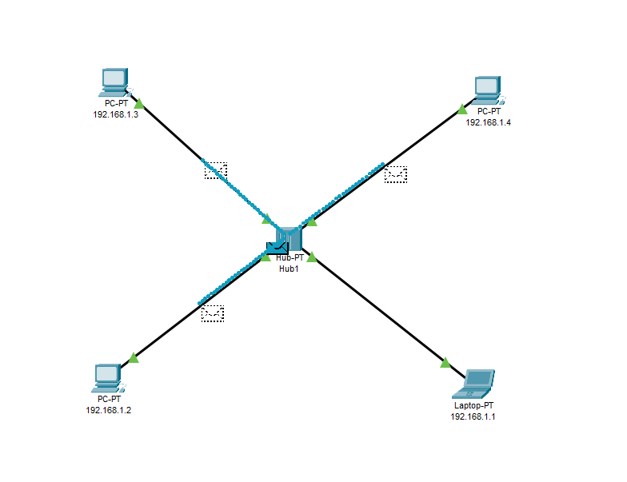

The message is broadcasted to all the connected devices.

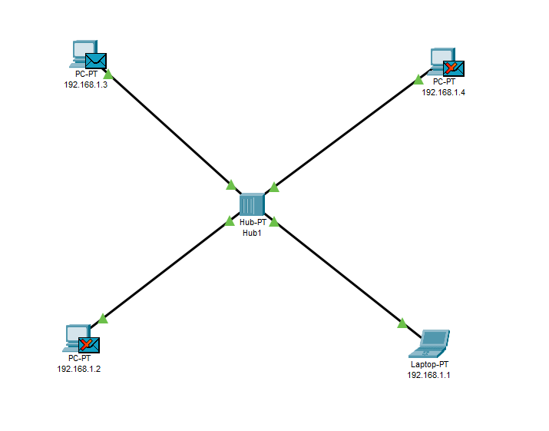

The message is accepted only be the PC-3 as it was the source.

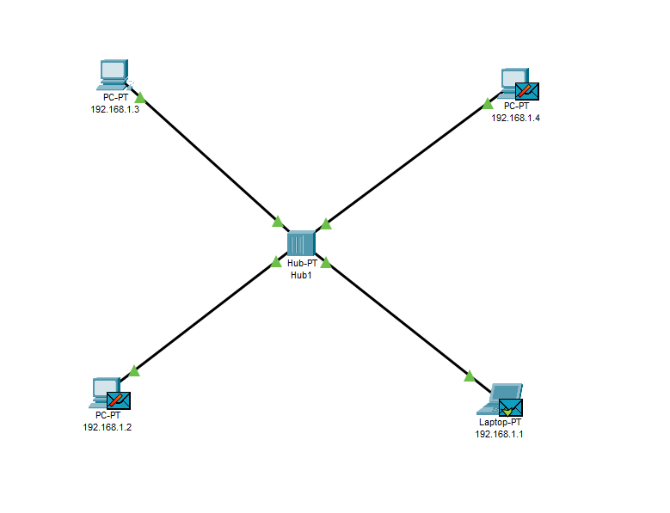

Second device is sending the message to the first device and it is received by only first device.

Result will be some kind of as follow:



**Using Switch:**

**Step 1:**

Place all the devices and place the switch at the center of them and connect them with the copper straight through cable.

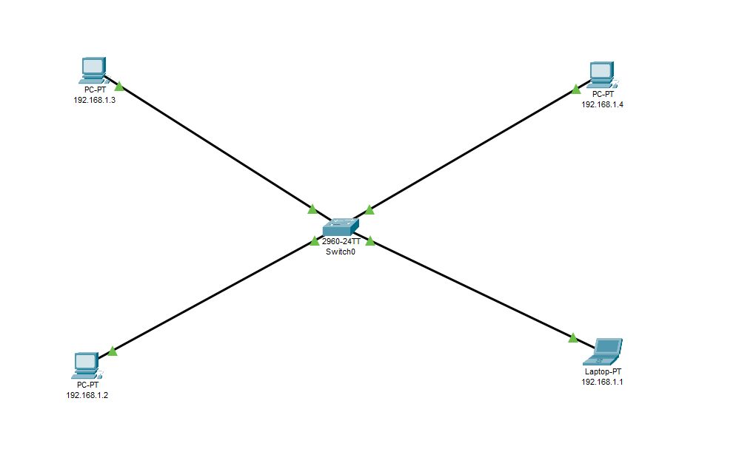

**Step 2:**

Now assign the IPs to each of the system.









**Step 3:**

Now select the message and add the source and the destination.

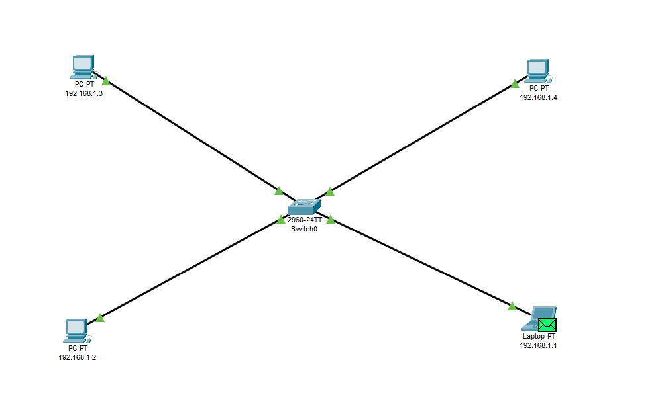

**Simulation:**



Message is sent to the Switch.

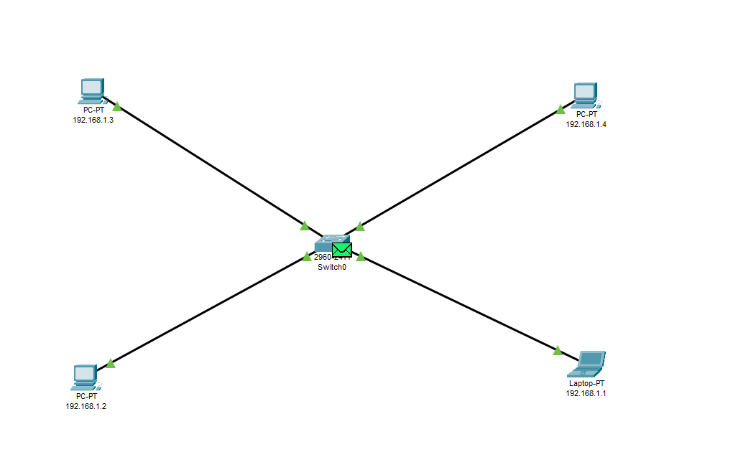

As the switch is an intelligent device it contains the IP table with itself so it matches the IP of the destination device and transfer the message to it.

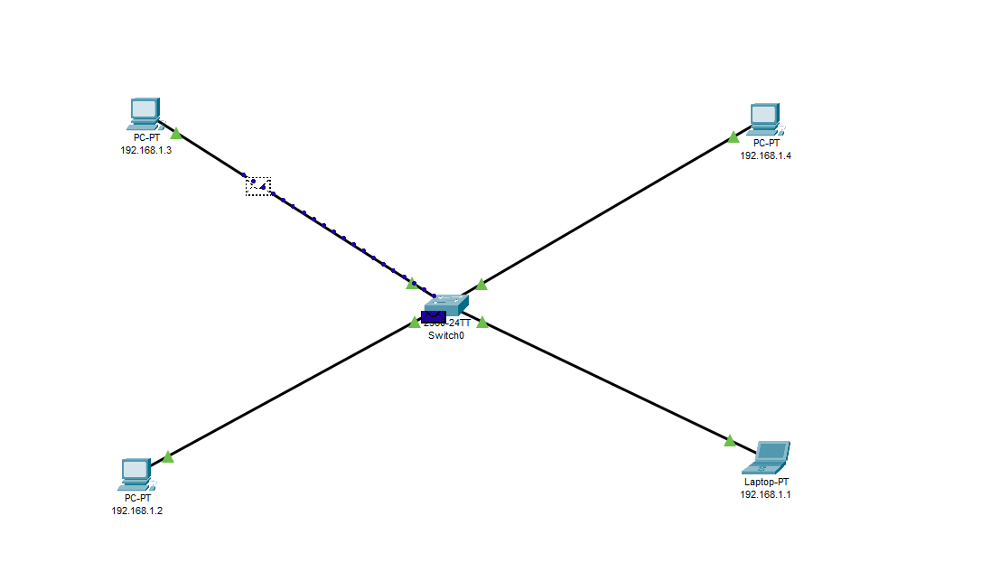

Now the receiver device is sending the reply to the sender device.

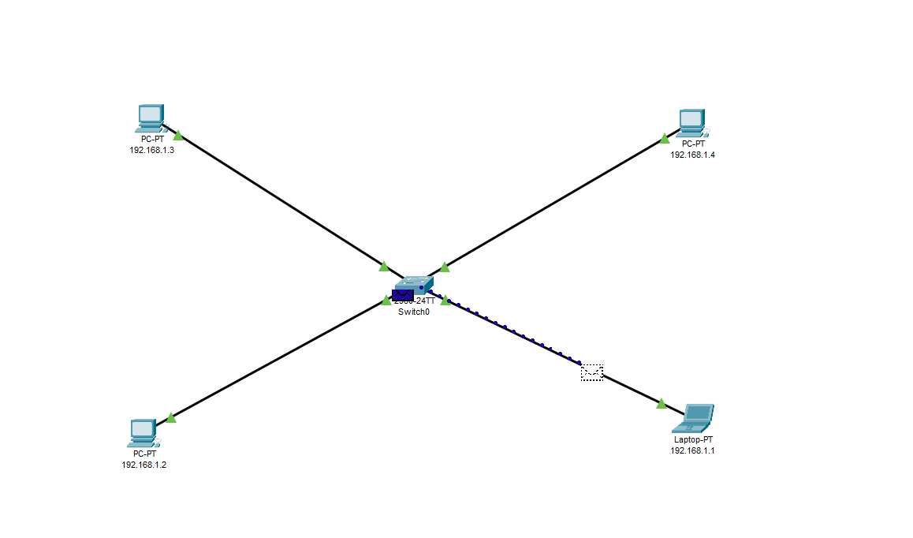

End result is as follow

